Brian Nhan Thien Chung & Nona Varnado

**ESS162 Lab4: CA source regions water budget**

**Include copies of the statewide Google Earth layers for AET, Precipitation, PET and P-ET. Describe in 2-4 sentences the main cause of the patterns for each of these layers (for example, what controls the spatial patterns of PET across CA?).**

*Precipitation*

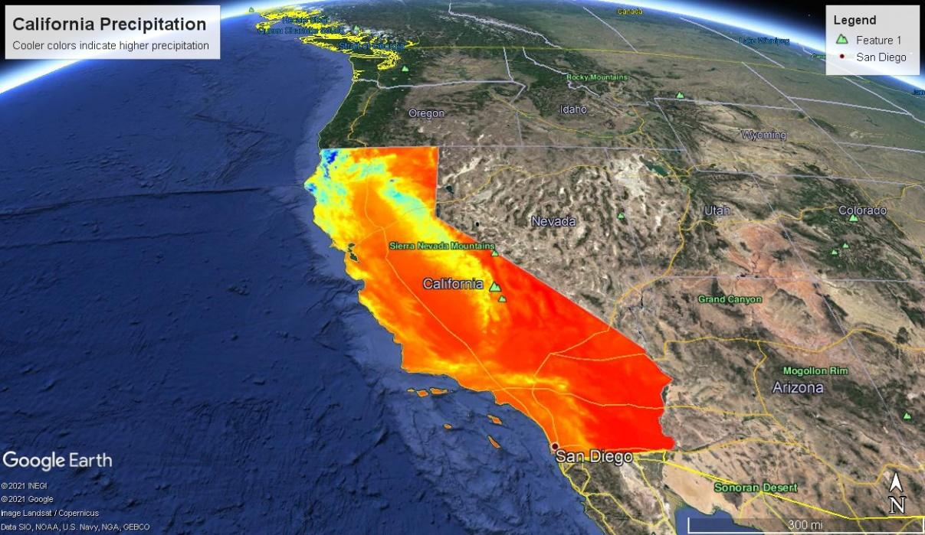

Patterns of precipitation can be explained by the topography of California. The Klamath Mountains, followed by the Sierra Nevada Mountains, have the highest precipitation in the state. This is by virtue of the process of orographic lifting: these mountain ranges lift humid, westerly air parcels that originated from the ocean, which expand due to the lower pressure with altitude and cool and condense into clouds. This produces high amounts of precipitation on the windward western sides of these mountain ranges. As air parcels move over the mountains, they then sink and compress, heating up adiabatically and the resulting high temperature produces a rain shadow -- which has much less precipitation -- on the eastern side of these mountains.

Although the Central Valley is on the western side of the Sierra Nevadas, it receives less precipitation than the Sierra Nevadas. This is because, by virtue of being a valley, the Central Valley does not have any mountain ranges to produce orographic lifting, making it less likely for air parcels to rise and cool and precipitation than the actual slopes of the Sierra Nevadas.

Patterns of precipitation in the eastern and southern portions of the state can also be explained by the topography. In essence, these portions of the state are too far inland; any maritime air would drop most of their precipitation before reaching these portions of the state. In addition, these regions also have shorter raining seasons due to the polar front moving into them later during the year and moving out of them earlier during the year than the northern parts of the state.

*AET*

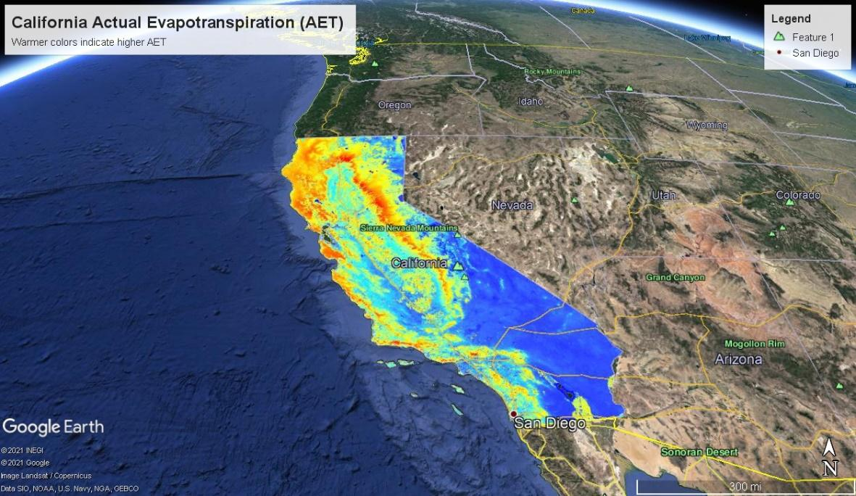

The geographical patterns of Actual Evapotranspiration mirror the patterns of precipitation: areas with high precipitation (northern coast, Klamath Mountains, and the Sierra Nevada Mountains) will also see high AET. This is due to the relatively high amount of rainfall compared to the rest of the state allowing for much more vegetation growth than other parts of the state, creating forests whose large amount of leaf area allows for high rates of transpiration, which results in high actual evapotranspiration. The regions of the state with cooler colors are rain shadows and are also further inland, which results in these regions receiving much less precipitation than the windward side of mountains and coastal regions. As a result, there tends to be less vegetation growth, resulting in less actual transpiration, and so lower AET.

*PET*

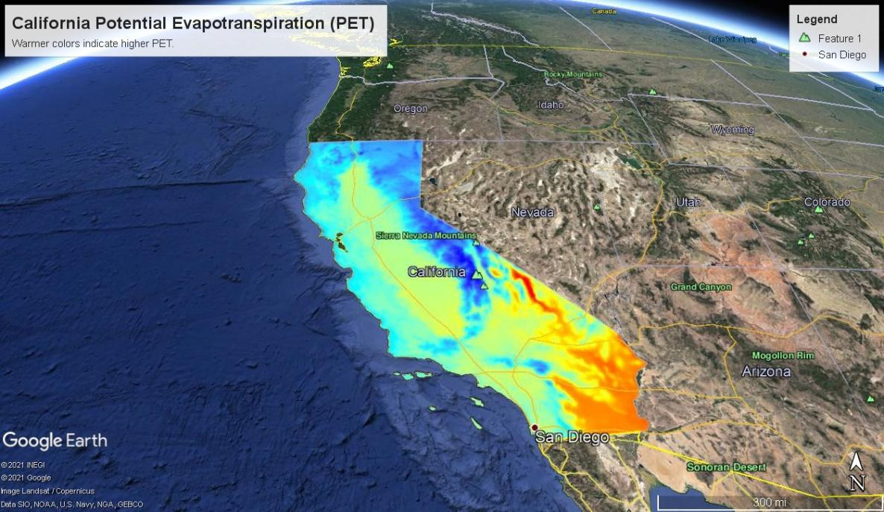

The geographical pattern of PET can be explained by its tight relationship with temperature, with mean annual maximum temperature explaining 91.2% of the geographical variation in potential evapotranspiration. As temperatures increase, saturation vapor pressure will increase, creating a larger difference between actual vapor pressure and saturation vapor pressure that would cause increased maximum rates of evapotranspiration possible to increase.

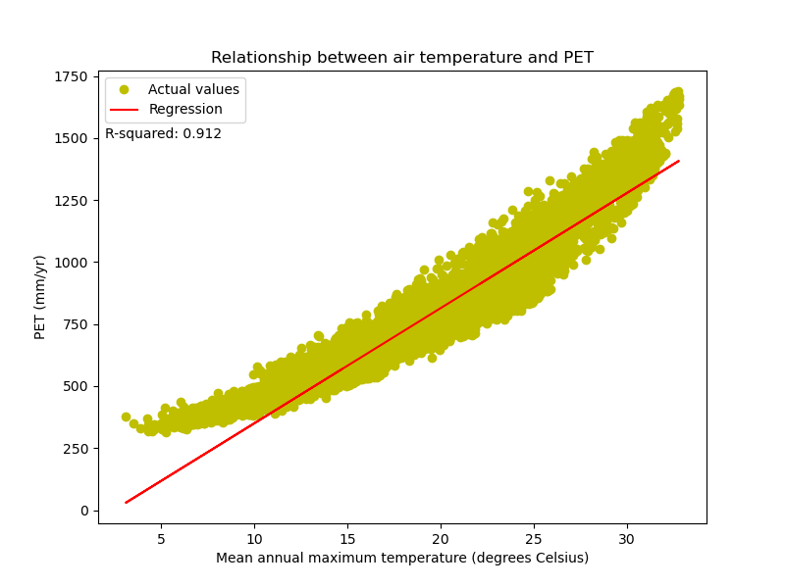

I would like to contrast the patterns of PET with the patterns of AET. The patterns of AET and PET seem to be opposites of each other; that is because, across the whole state, the dominant controls of AET and PET differ from each other. AET is controlled by vegetation, which is controlled by the amount of precipitation, while PET is controlled by differences between saturation vapor pressure and actual vapor pressure, which is controlled by temperature.

*Runoff (P – ET)*

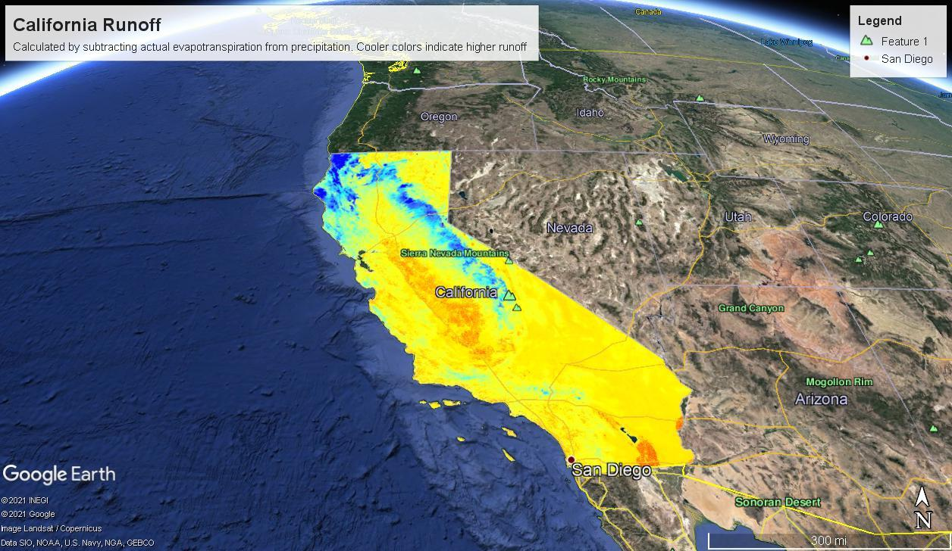

Geographical variation of runoff mirrors that of precipitation and evapotranspiration, which is easy to understand intuitively because runoff is calculated by precipitation and evapotranspiration. However, I believe that the variability of runoff is primarily determined by precipitation. As precipitation increases, more water will be available for vegetation to grow, resulting in biomes with heavier vegetation growth. These heavily vegetated biomes will have higher AET relative to less vegetated biomes. Therefore, as a consequence of increased precipitation, AET will also increase. However, AET does not keep up with precipitation enough to keep runoff constant. Instead, precipitation increases outpace AET increases, resulting in areas with high precipitation also having high amounts of runoff while areas with low precipitation also having low runoff.

**It is expected to rain 2 inches at UCI over the next few days. How many acre feet of water will fall on Aldrich Park during the time?**

Diameter of Aldrich Park = 282.61 m

Pi * (282.61 m/2)^2 * (1 acre/4046.86 m^2) * 2 in * (1 ft/12 in) = 2.58 acre-ft

Approximately 2.58 acre-ft of water will fall over Aldrich Park.

**What is the total annual runoff (P-ET) in Acre-ft produced by the Sierra Nevada ecozone? (the area of the Sierra Nevada is 52000 km2)**

Since precipitation and evapotranspiration in the data are given in units of length (mm) rather than volume (m^3), the initial units of runoff will also be in units of length. Each calculated value of runoff represents runoff at a specific location. I calculated the mean of these values to calculate the average runoff height produced by the ecoregion, producing a value of 528.72 mm.

528.72 mm * 52,000 km^2 * (1 m/1000 mm) * (1,000,000 m^2/1 km^2) * (1 ft/0.3048 m) * (1 acre/4046.86 m^2) * (1 MAF/10^6 AF) = 22.3 million acre-ft

The Sierra Nevada ecoregion produces roughly 22.3 million acre-ft of runoff annually.

**Identify the Upper Kings River Basin and include a Google Earth image of P-ET, the watershed boundary and the location of hydroelectric plants. Describe the general geography**

*Watershed boundary and hydroelectric plants*

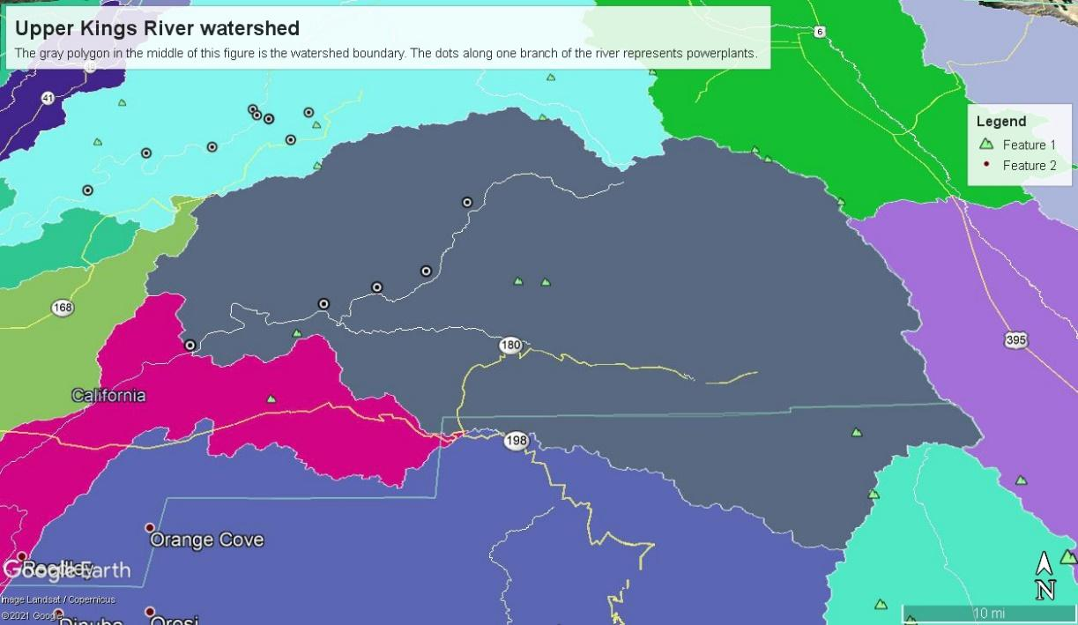

The dots along the streams represent the hydroelectric power plants.

*Upper Kings River P – ET*

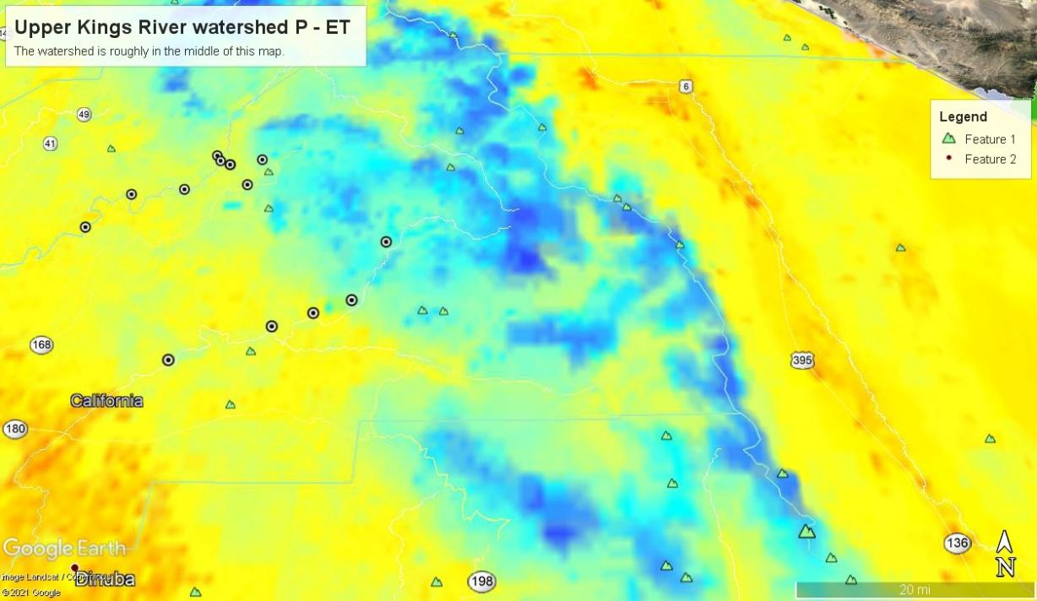

*Upper Kings River watershed terrain*

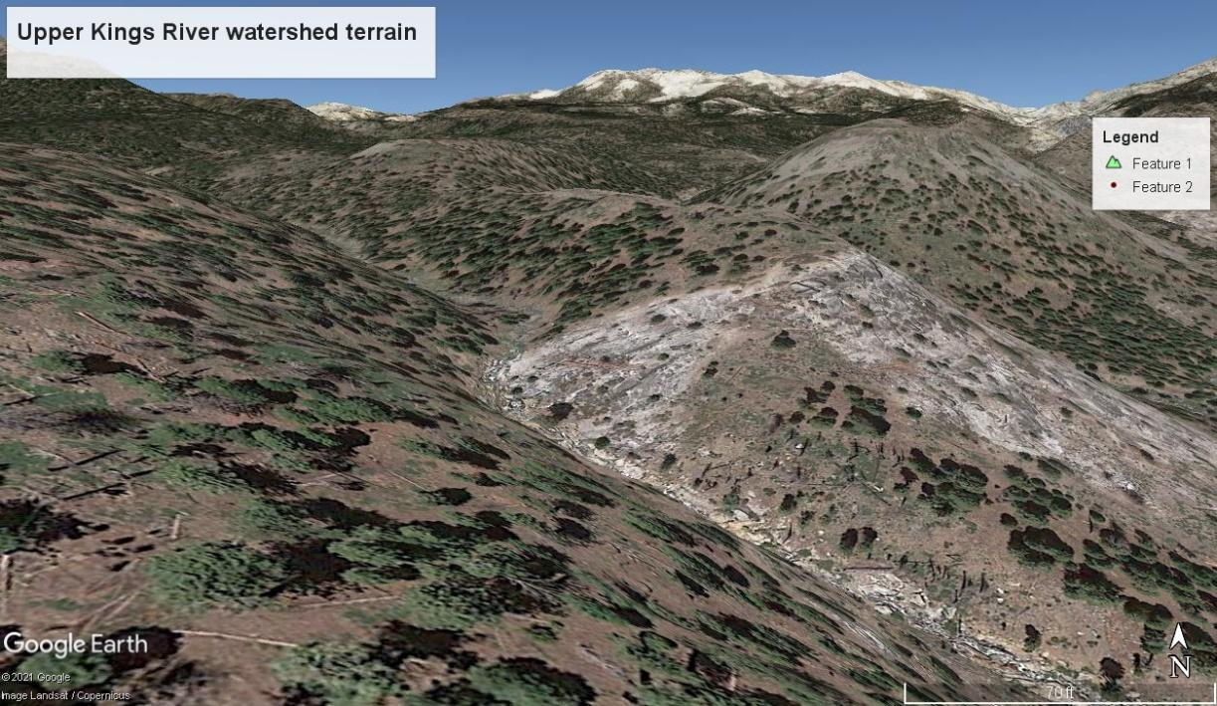

The terrain is fairly hilly with relatively few flat surfaces, even far away from the river branches. The terrain becomes even more extreme near the river branches, with the slopes being much more extreme near the river branches. Overall, this hilly terrain makes the streams in this watershed fairly straight rather than meandering. The steep slopes force the water to descend and limits horizontal movement, resulting in fairly straight streams in this watershed. The high vertical drops that water must undergo using these steep slopes is also conducive for generating electricity, enabling 5 hydroelectric power plants to be built along the streams in this watershed.

This watershed contains the source of the Kings River itself. As a result, this watershed is high in elevation, allowing for low temperatures that result in relatively more precipitation than at lower elevations of the Kings River. However, the hilly terrain results in a decoupling of the relationship between precipitation with elevation and temperature, as described in the following section.

**Plot and include graphs for the elevation dependence of precip, PET, AET, P-ET and (P-ET)/P in the Kings River basin. Explain the patterns. Where is most of the water produced (higher P-ETs) and why is water production greatest there?**

*Effects of elevation on various hydrographical variables*

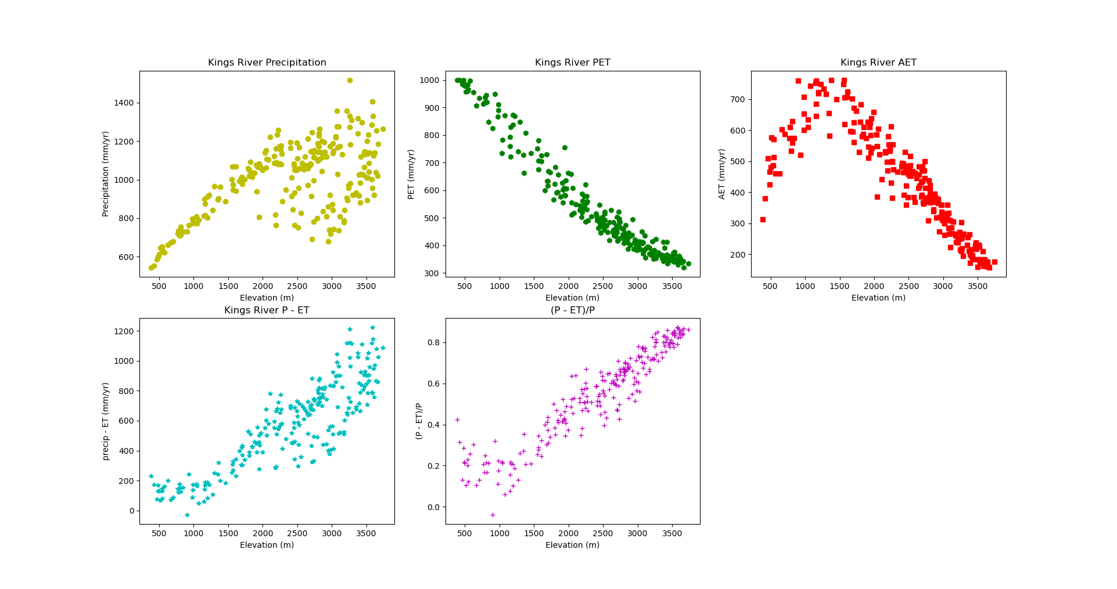

Elevation has a strong relationship within precipitation that decreases at elevations higher than roughly 2000 m. The strong relationship at lower elevations can be explained by orographic lifting: as air parcels move eastward on the watershed, it is forced to rise by the increasing elevation, forcing it to expand, cool, and precipitate more rain as it rises.

However, the relationship weakens at elevations higher than 2000 m, indicating that the effect of orographic lifting weakens at higher elevations. The weaker relationship between elevation and precipitation indicates that air parcels are experiencing rain shadow effects from the hilly terrain at higher elevation: an air parcel can be forced to rise over a hill, causing it to rain over the windward side of the hill, and then rise over another hill of similar elevation but will not cause as much precipitation as the previous hill due to having lost some of its moisture at the previous hill. As noted above, the terrain of the Upper Kings River watershed tends to be fairly hilly, and the successive movements over successive hills results in very different precipitation at hills of similar elevations over 2000 m.

The relationship between PET and elevation tends to be much stronger, as noted by the plot in the upper middle of this figure as well as the figure of air temperature and PET of the entire state. This is due to the strong nature of the underlying relationships of PET with temperature and temperature with elevation. Increases in elevation are tightly linked with, and causes, decreases in temperature, which, in turn, causes a decrease in saturation vapor pressure which causes potential rates of evaporation to decrease.

In order to explain the relationship between AET and elevation, an understanding of the underlying vegetation is needed. As elevation increases until roughly 1500 m, AET also increases, and this is due to the increasing amount of vegetation with elevation until roughly 1500 m. The increasing amount of vegetation causes transpiration to increase, resulting in the positive trend between elevation and AET until 1500 m. After 1500 m, the trend reverses, with increasing elevation resulting in decreased AET. Vegetation growth decreases at elevations higher than 1500 m, and this results in decreasing influence of vegetation on evapotranspiration. AET increasingly becomes controlled by temperature, and as temperature decreases with increasing elevation, AET is forced to decrease as well.

The relationship between elevation and the amount of runoff (P – ET) is somewhat similar to the relationship between elevation and precipitation, although it is offset by decreases in AET with increasing elevation. As a result, this relationship is positive. Runoff tends to increase with elevation. At altitudes below 1500 m, precipitation and evapotranspiration both increasing with elevation. Although both of these variables increase, increases in precipitation outpaces increases in AET, resulting in runoff increasing with elevation as well. The influence of precipitation on runoff decreases past elevations of 1500 m due to the hilly terrain causing rain shadow effects that results in widely varying precipitation. However, the amount of runoff continues to increase, as there is now a fairly consistent negative trend between AET and elevation where AET decreases with elevation past 1500 m. As a result, past 1500 m, the increasing runoff is influenced more by the decreasing AET.

The relationships that underlie the total amount of runoff also underlies the fraction of precipitation that becomes runoff (P – ET)/P. As elevation initially increases, precipitation increases outpace increases in evapotranspiration, meaning that the fraction of precipitation that becomes runoff increases. However, as the influence of precipitation decreases at higher altitudes, evapotranspiration decreases with elevation, meaning that the fraction of precipitation that becomes evapotranspiration decreases, and so the fraction of precipitation that becomes runoff increases.

**Calculate how much the amount of runoff produced by the Kings River might change with 6oC warming.**

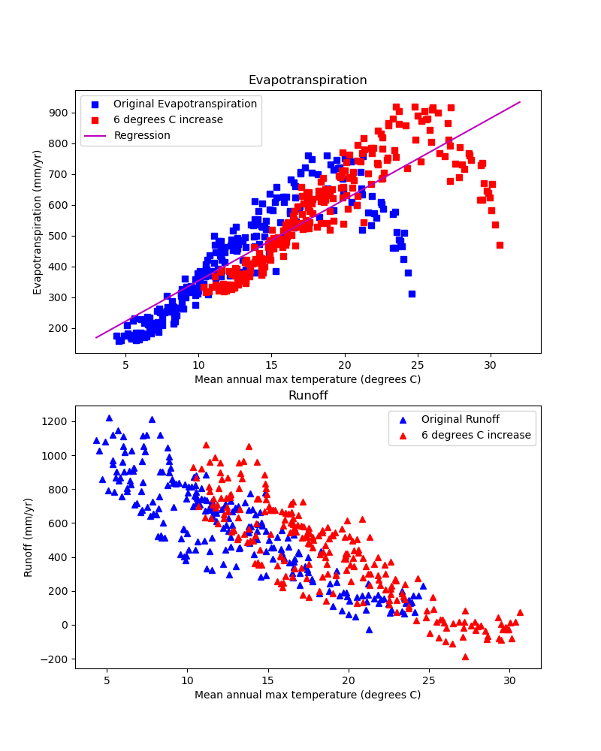

Runoff is calculated by subtracting AET from precipitation. AET is assumed to change with climate change, while precipitation is assumed to be constant. Linear regression (shown by the purple line in the top subplot) was conducted on AET and temperature over the Kings River watershed. A change in evapotranspiration from a 6 degrees increase is then calculated by the relationship from this linear regression. 6 degrees is added to the temperature values for each location, and the change in evapotranspiration calculated from the linear regression is also added to the original AET values. This results in the red points on the upper plot of the figure that shows a shift upwards to the right in evapotranspiration. These new values of evapotranspiration are then subtracted from the original values for precipitation, producing predicted runoff with 6 degrees Celsius rise (shown here in red).

The overall relationship between AET and temperature is fairly positive, with increasing temperature generally followed by increasing AET. As a result, a 6 degrees rise results in an increase in evapotranspiration, which results in reduced runoff. Evapotranspiration is predicted to rise, on average, by 158.185 mm/yr. Because precipitation is assumed to remain constant, runoff is predicted to drop by 158.185 mm/yr over the whole watershed. Given that this value is the average change in runoff height over the whole watershed, the change in runoff volume can be estimated. This watershed has an area of 3999.19 km^2. Multiplying the runoff height by the watershed area yields a decrease in runoff volume of 0.632612 cubic kilometers, or 512,867 acre-ft.

Linear regression of evapotranspiration and temperature

Evapotranspiration = (26.36 mm/C)*temperature + 90.14 mm

Calculating change in runoff height

Evapotranspiration (6) = (26.36 mm/C)*6 C + 90.14 mm = 248.33 mm

Evapotranspiration (0) = (26.36 mm/C)*0 C + 90.14 mm = 90.14 mm

Change in evapotranspiration = Evapotranspiration (6) – Evapotranspiration (0) = 158.15 mm

Because precipitation remains constant, the change in evapotranspiration is equal to the change in runoff. Therefore, runoff will decrease by 158.15 mm.

Calculating change in runoff volume

The area of this watershed, as obtained from the shapefile, is 3999.19 square kilometers

158.185 mm * 3999.19 km^2 * (1 km/1,000,000 mm) = 0.632612 cubic kilometers

0.632612 km^3 * (1000^3 m^3/1 km^3) * (1 acre/4046.86 m^2) * (1 ft/0.3048 m) = 512,867 acre-ft

Therefore, the annual volume of runoff will decrease by approximately 0.633 cubic kilometers, or approximately 513,000 acre-ft.